1-npm

📦 What Is npm?
# Source: AI Source: Provided by: [Data Path: Persons Table -> ID Column: 1, Name_En Column: Motasem Essam] -> From: [ChatGPT] on [1/26/2026]
npm stands for Node Package Manager — it’s the default package manager for Node.js. It allows developers to install, share, and manage code packages (JavaScript libraries or tools) from the npm registry.

✅ Simple Definition:
# Source: AI Source: Provided by: [Data Path: Persons Table -> ID Column: 1, Name_En Column: Motasem Essam] -> From: [ChatGPT] on [1/26/2026]
npm helps JavaScript developers manage third-party code — like libraries, tools, and dependencies — and run scripts for building, testing, and deploying apps.

🧠 Real-Life Analogy:
# Source: AI Source: Provided by: [Data Path: Persons Table -> ID Column: 1, Name_En Column: Motasem Essam] -> From: [ChatGPT] on [1/26/2026]
Think of npm like an app store for JavaScript:
- You can install tools (e.g. React, Vue, Axios)
- You can publish your own packages
- It helps you organize your project’s dependencies

npm registry

🌐 What Is the npm Registry?
# Source: AI Source: Provided by: [Data Path: Persons Table -> ID Column: 1, Name_En Column: Motasem Essam] -> From: [ChatGPT] on [1/26/2026]
The npm registry is a public online database (like a library or store) that contains over 2 million JavaScript packages (also called modules). These packages can be downloaded, shared, and managed using the npm CLI (command-line interface).

✅ Simple Definition:
# Source: AI Source: Provided by: [Data Path: Persons Table -> ID Column: 1, Name_En Column: Motasem Essam] -> From: [ChatGPT] on [1/26/2026]
The npm registry is where npm stores and retrieves JavaScript packages — it's like the “app store” for Node.js projects.

📦 Official URL:
# Source: AI Source: Provided by: [Data Path: Persons Table -> ID Column: 1, Name_En Column: Motasem Essam] -> From: [ChatGPT] on [1/26/2026]
You can browse it at:
👉 https://www.npmjs.com

🔧 What You Can Do with It:
# Source: AI Source: Provided by: [Data Path: Persons Table -> ID Column: 1, Name_En Column: Motasem Essam] -> From: [ChatGPT] on [1/26/2026]
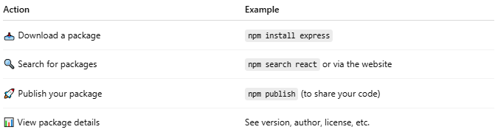

Action | Example
📥 Download a package | npm install express
🔍 Search for packages | npm search react or via the website
🚀 Publish your package | npm publish (to share your code)
📊 View package details | See version, author, license, etc.

📁 Example Package (like axios):
# Source: AI Source: Provided by: [Data Path: Persons Table -> ID Column: 1, Name_En Column: Motasem Essam] -> From: [ChatGPT] on [1/26/2026]
Visit: https://www.npmjs.com/package/axios
You’ll find:
- Description of the library
- Installation command
- Version history
- Dependencies
- README documentation

🔒 Public vs Private
# Source: AI Source: Provided by: [Data Path: Persons Table -> ID Column: 1, Name_En Column: Motasem Essam] -> From: [ChatGPT] on [1/26/2026]
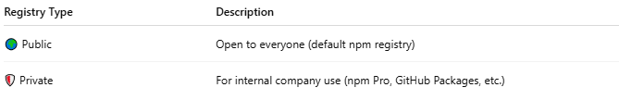
Registry Type | Description
🌍 Public | Open to everyone (default npm registry)
🛡️ Private | For internal company use (npm Pro, GitHub Packages, etc.)

📌 Summary
# Source: AI Source: Provided by: [Data Path: Persons Table -> ID Column: 1, Name_En Column: Motasem Essam] -> From: [ChatGPT] on [1/26/2026]
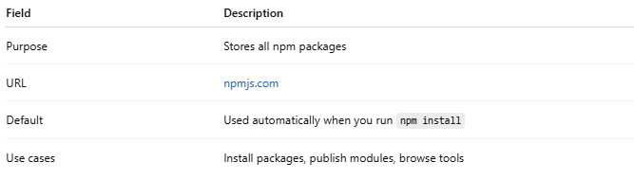

Field | Description
Purpose | Stores all npm packages
URL | npmjs.com
Default | Used automatically when you run npm install
Use cases | Install packages, publish modules, browse tools

package.json and package-lock.json

package.json

📦 What Is package.json?
# Source: AI Source: Provided by: [Data Path: Persons Table -> ID Column: 1, Name_En Column: Motasem Essam] -> From: [ChatGPT] on [1/26/2026]
package.json is the configuration file for Node.js projects (JavaScript runtime).
It defines the metadata, dependencies, scripts, and settings your project needs to run and develop properly.
It’s the Node.js equivalent of composer.json in PHP.

🧩 Example package.json
# Source: AI Source: Provided by: [Data Path: Persons Table -> ID Column: 1, Name_En Column: Motasem Essam] -> From: [ChatGPT] on [1/26/2026]
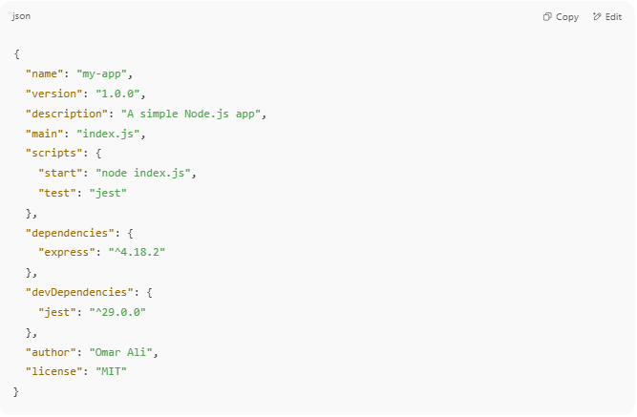
{
"name": "my-app",
"version": "1.0.0",
"description": "A simple Node.js app",
"main": "index.js",
"scripts": {
"start": "node index.js",
"test": "jest"
},
"dependencies": {
"express": "^4.18.2"
},
"devDependencies": {
"jest": "^29.0.0"
},
"author": "Omar Ali",
"license": "MIT"
}

🧠 Key Sections Explained
# Source: AI Source: Provided by: [Data Path: Persons Table -> ID Column: 1, Name_En Column: Motasem Essam] -> From: [ChatGPT] on [1/26/2026]
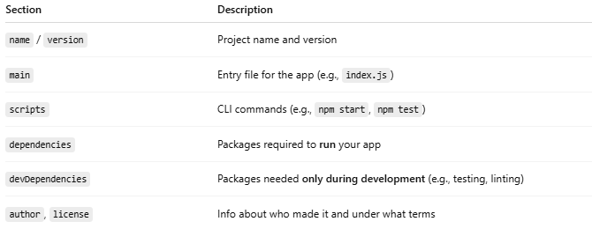

Section | Description
name / version | Project name and version
main | Entry file for the app (e.g., index.js)
scripts | CLI commands (e.g., npm start, npm test)
dependencies | Packages required to run your app
devDependencies | Packages needed only during development (e.g., testing, linting)
author, license | Info about who made it and under what terms

✅ Why Is It Important?
# Source: AI Source: Provided by: [Data Path: Persons Table -> ID Column: 1, Name_En Column: Motasem Essam] -> From: [ChatGPT] on [1/26/2026]
- Automatically manages your project’s dependencies
- Helps others install and run your project with just npm install
- Enables npm run custom commands
- Required for publishing to npm registry

🔁 Related File: package-lock.json
# Source: AI Source: Provided by: [Data Path: Persons Table -> ID Column: 1, Name_En Column: Motasem Essam] -> From: [ChatGPT] on [1/26/2026]
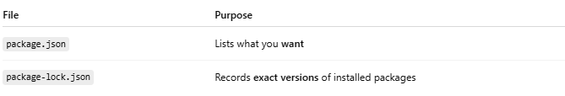

File | Purpose
package.json | Lists what you want
package-lock.json | Records exact versions of installed packages

🔨 Common Commands
# Source: AI Source: Provided by: [Data Path: Persons Table -> ID Column: 1, Name_En Column: Motasem Essam] -> From: [ChatGPT] on [1/26/2026]
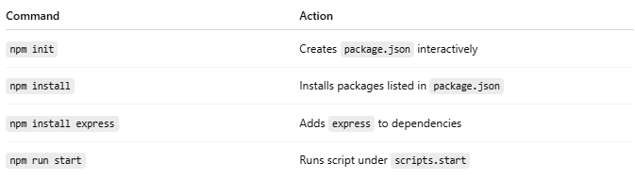

Command | Action
npm init | Creates package.json interactively
npm install | Installs packages listed in package.json
npm install express | Adds express to dependencies
npm run start | Runs script under scripts.start

🧪 Mini Example Use Case
# Source: AI Source: Provided by: [Data Path: Persons Table -> ID Column: 1, Name_En Column: Motasem Essam] -> From: [ChatGPT] on [1/26/2026]
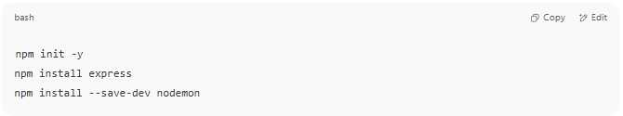
npm init -y
npm install express
npm install --save-dev nodemon

Then your package.json will include:
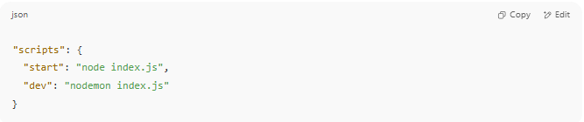
"scripts": {
"start": "node index.js",
"dev": "nodemon index.js"
}

Now you can run:
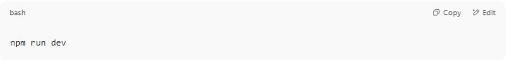
npm run dev

How to "Runs a custom script defined in package.json"?
# Source: AI Source: Provided by: [Data Path: Persons Table -> ID Column: 1, Name_En Column: Motasem Essam] -> From: [ChatGPT] on [1/26/2026]
In an npm-based project, the package.json file has a section called "scripts".
These scripts are commands you define yourself — and then run using:
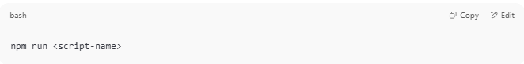
npm run <script-name>

📦 Example: package.json
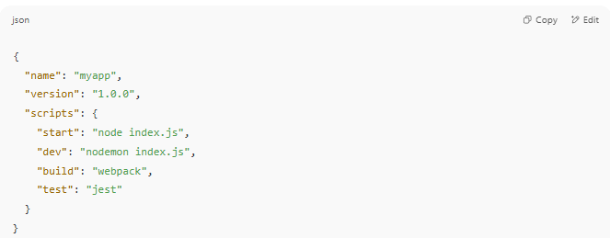
{
"name": "myapp",
"version": "1.0.0",
"scripts": {
"start": "node index.js",
"dev": "nodemon index.js",
"build": "webpack",
"test": "jest"
}
}

✅ What Each Script Does:
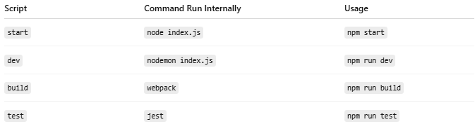

Script | Command Run Internally | Usage
start | node index.js | npm start
dev | nodemon index.js | npm run dev
build | webpack | npm run build
test | jest | npm run test

🚨 Except for start and test, you must use npm run <script>.

🧠 Why Use Scripts?
- ✅ Shorten long commands
- 🚀 Automate workflows (build, deploy, lint, etc.)
- 🧪 Run tests or start development servers
🔧 Custom Script Example:
You could define:
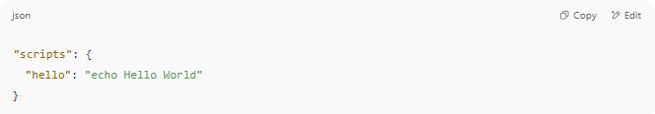
"scripts": {
"hello": "echo Hello World"
}

Then run it: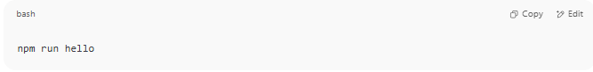
npm run hello

Output:
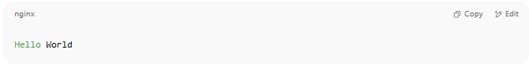
Hello World

🧾 Summary
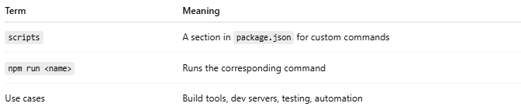

Term | Meaning
scripts | A section in package.json for custom commands
npm run <name> | Runs the corresponding command
Use cases | Build tools, dev servers, testing, automation

package-lock.json

📄 What Is package-lock.json?
# Source: AI Source: Provided by: [Data Path: Persons Table -> ID Column: 1, Name_En Column: Motasem Essam] -> From: [ChatGPT] on [1/26/2026]
package-lock.json is a file automatically generated by npm (Node.js package manager) when you install dependencies using:
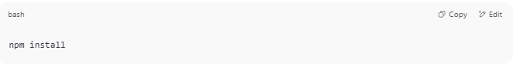
npm install

It works alongside package.json to lock the exact versions of every installed package (including sub-dependencies), so your project behaves the same for everyone, everywhere.

📦 Purpose
# Source: AI Source: Provided by: [Data Path: Persons Table -> ID Column: 1, Name_En Column: Motasem Essam] -> From: [ChatGPT] on [1/26/2026]
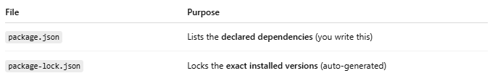

File | Purpose
package.json | Lists the declared dependencies (you write this)
package-lock.json | Locks the exact installed versions (auto-generated)

🧠 Why It Matters
# Source: AI Source: Provided by: [Data Path: Persons Table -> ID Column: 1, Name_En Column: Motasem Essam] -> From: [ChatGPT] on [1/26/2026]
Without package-lock.json, if you say:
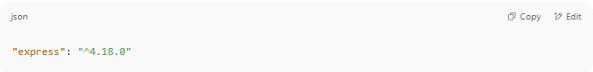
"express": "^4.18.0"

Then:
- On one machine: npm might install 4.18.2
- On another machine: npm might install 4.18.3
➡️ This can cause inconsistent behavior or bugs.
With package-lock.json:
- Everyone gets exactly the same version — including nested dependencies like express → accepts → mime-types → ...

🔍 Example Snippet
# Source: AI Source: Provided by: [Data Path: Persons Table -> ID Column: 1, Name_En Column: Motasem Essam] -> From: [ChatGPT] on [1/26/2026]
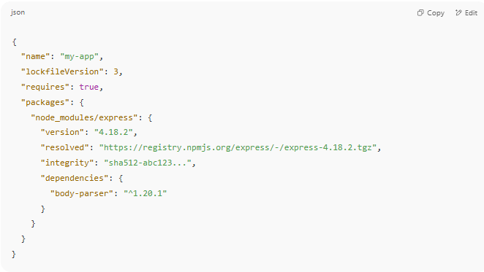
{
"name": "my-app",
"lockfileVersion": 3,
"requires": true,
"packages": {
"node_modules/express": {
"version": "4.18.2",
"resolved": "https://registry.npmjs.org/express/-/express-4.18.2.tgz",
"integrity": "sha512-abc123...",
"dependencies": {
"body-parser": "^1.20.1"
}
}
}
}

✅ What It Contains
# Source: AI Source: Provided by: [Data Path: Persons Table -> ID Column: 1, Name_En Column: Motasem Essam] -> From: [ChatGPT] on [1/26/2026]
- 📌 Exact version numbers
- 🔗 URLs to download packages
- 🔐 Hashes (integrity) to verify integrity
- 📁 Full dependency tree, including sub-dependencies

🔒 Why You Should Commit It
# Source: AI Source: Provided by: [Data Path: Persons Table -> ID Column: 1, Name_En Column: Motasem Essam] -> From: [ChatGPT] on [1/26/2026]
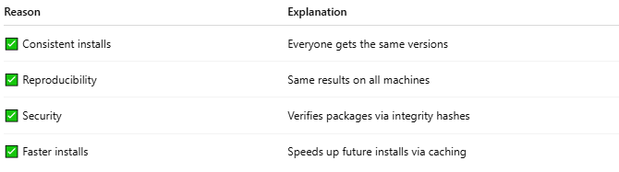
Reason | Explanation
✅ Consistent installs | Everyone gets the same versions
✅ Reproducibility | Same results on all machines
✅ Security | Verifies packages via integrity hashes
✅ Faster installs | Speeds up future installs via caching

⚠️ Common Confusion
# Source: AI Source: Provided by: [Data Path: Persons Table -> ID Column: 1, Name_En Column: Motasem Essam] -> From: [ChatGPT] on [1/26/2026]
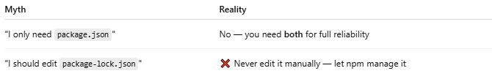

Myth | Reality
"I only need package.json" | No — you need both for full reliability
"I should edit package-lock.json" | ❌ Never edit it manually — let npm manage it

🔄 When Is It Updated?
# Source: AI Source: Provided by: [Data Path: Persons Table -> ID Column: 1, Name_En Column: Motasem Essam] -> From: [ChatGPT] on [1/26/2026]
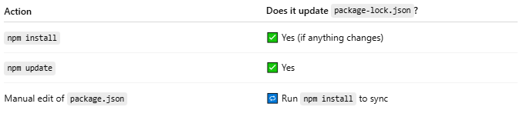

Action | Does it update package-lock.json?
npm install | ✅ Yes (if anything changes)
npm update | ✅ Yes
Manual edit of package.json | 🔁 Run npm install to sync

🧪 Bonus Tip: Reinstall with Lock
# Source: AI Source: Provided by: [Data Path: Persons Table -> ID Column: 1, Name_En Column: Motasem Essam] -> From: [ChatGPT] on [1/26/2026]
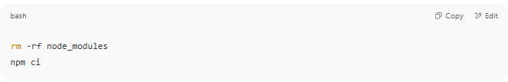

rm -rf node_modules
npm ci

- npm ci = clean install using package-lock.json only (used in CI/CD or production)

🧠 Summary
# Source: AI Source: Provided by: [Data Path: Persons Table -> ID Column: 1, Name_En Column: Motasem Essam] -> From: [ChatGPT] on [1/26/2026]
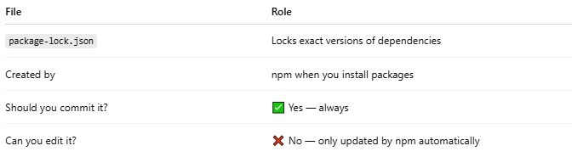
File | Role
package-lock.json | Locks exact versions of dependencies
Created by | npm when you install packages
Should you commit it? | ✅ Yes — always
Can you edit it? | ❌ No — only updated by npm automatically

npm CLI

💻 What Is npm CLI?
# Source: AI Source: Provided by: [Data Path: Persons Table -> ID Column: 1, Name_En Column: Motasem Essam] -> From: [ChatGPT] on [1/26/2026]
npm CLI stands for Node Package Manager Command-Line Interface — it's the tool you use in the terminal to interact with the npm registry, manage your project’s dependencies, run scripts, and publish packages.

✅ Simple Definition:
# Source: AI Source: Provided by: [Data Path: Persons Table -> ID Column: 1, Name_En Column: Motasem Essam] -> From: [ChatGPT] on [1/26/2026]
The npm CLI is the command-line tool that lets you install, manage, and run JavaScript packages using simple terminal commands like npm install, npm run, etc.

📦 Comes With:
# Source: AI Source: Provided by: [Data Path: Persons Table -> ID Column: 1, Name_En Column: Motasem Essam] -> From: [ChatGPT] on [1/26/2026]
When you install Node.js, the npm CLI is included automatically.
You can check your version with:
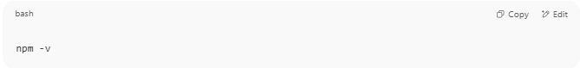
npm -v

🔧 Common npm CLI Commands
# Source: AI Source: Provided by: [Data Path: Persons Table -> ID Column: 1, Name_En Column: Motasem Essam] -> From: [ChatGPT] on [1/26/2026]
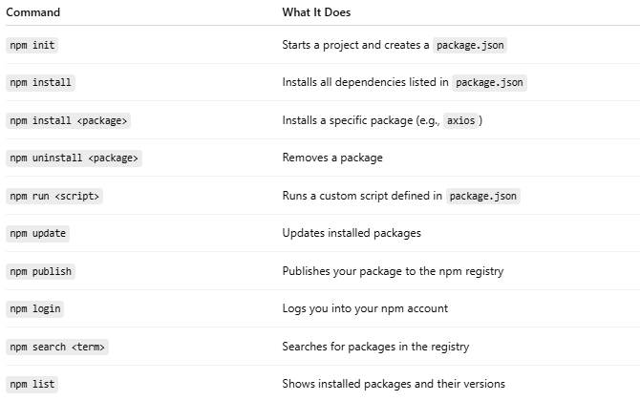
Command | What It Does
npm init | Starts a project and creates a package.json
npm install | Installs all dependencies listed in package.json
npm install <package> | Installs a specific package (e.g., axios)
npm uninstall <package> | Removes a package
npm run <script> | Runs a custom script defined in package.json
npm update | Updates installed packages
npm publish | Publishes your package to the npm registry
npm login | Logs you into your npm account
npm search <term> | Searches for packages in the registry
npm list | Shows installed packages and their versions

🧪 Example: Installing Axios
# Source: AI Source: Provided by: [Data Path: Persons Table -> ID Column: 1, Name_En Column: Motasem Essam] -> From: [ChatGPT] on [1/26/2026]
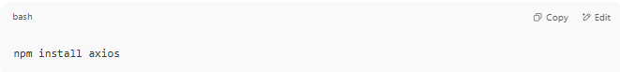
npm install axios

Creates:
- node_modules/ folder (stores the code)
- Adds axios to your package.json under "dependencies"

📁 Example Script in package.json
# Source: AI Source: Provided by: [Data Path: Persons Table -> ID Column: 1, Name_En Column: Motasem Essam] -> From: [ChatGPT] on [1/26/2026]
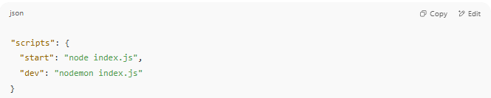
"scripts": {
"start": "node index.js",
"dev": "nodemon index.js"
}

You can run:
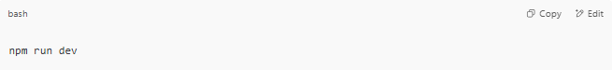
npm run dev

📌 Summary
# Source: AI Source: Provided by: [Data Path: Persons Table -> ID Column: 1, Name_En Column: Motasem Essam] -> From: [ChatGPT] on [1/26/2026]
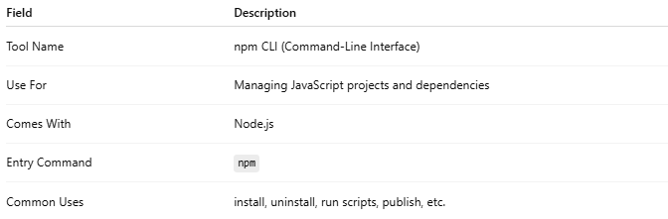
Field | Description
Tool Name | npm CLI (Command-Line Interface)
Use For | Managing JavaScript projects and dependencies
Comes With | Node.js
Entry Command | npm
Common Uses | install, uninstall, run scripts, publish, etc.

🔧 Key Features
# Source: AI Source: Provided by: [Data Path: Persons Table -> ID Column: 1, Name_En Column: Motasem Essam] -> From: [ChatGPT] on [1/26/2026]
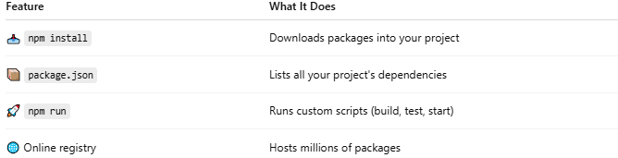

Feature | What It Does
📥 npm install | Downloads packages into your project
📦 package.json | Lists all your project's dependencies
🚀 npm run | Runs custom scripts (build, test, start)
🌐 Online registry | Hosts millions of packages

🛠️ How It's Used

✅ Installing a package
# Source: AI Source: Provided by: [Data Path: Persons Table -> ID Column: 1, Name_En Column: Motasem Essam] -> From: [ChatGPT] on [1/26/2026]
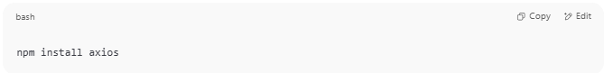
npm install axios

✅ Creating a package.json file
# Source: AI Source: Provided by: [Data Path: Persons Table -> ID Column: 1, Name_En Column: Motasem Essam] -> From: [ChatGPT] on [1/26/2026]
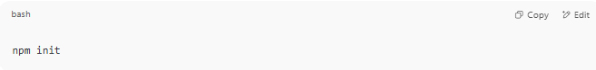
npm init

✅ Running a build script
# Source: AI Source: Provided by: [Data Path: Persons Table -> ID Column: 1, Name_En Column: Motasem Essam] -> From: [ChatGPT] on [1/26/2026]
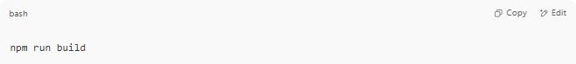
npm run build

📦 What Is the package.json File?
# Source: AI Source: Provided by: [Data Path: Persons Table -> ID Column: 1, Name_En Column: Motasem Essam] -> From: [ChatGPT] on [1/26/2026]
This file tracks:
- Your dependencies
- Project name and version
- Scripts (e.g., start server, build app)
- Metadata (author, license, etc.)
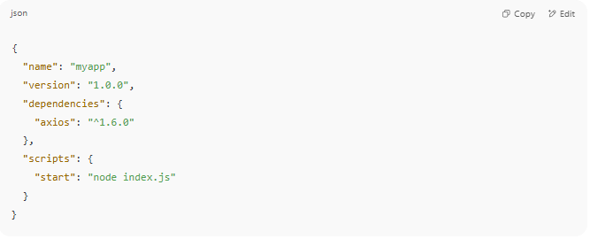
{
"name": "myapp",
"version": "1.0.0",
"dependencies": {
"axios": "^1.6.0"
},
"scripts": {
"start": "node index.js"
}
}

Full npm Example (Step-by-Step)

1️⃣ Install Node.js
# Source: AI Source: Provided by: [Data Path: Persons Table -> ID Column: 1, Name_En Column: Motasem Essam] -> From: [ChatGPT] on [1/26/2026]

First install Node.js from its official website.
npm is installed automatically with it.

Example:
Check installation:
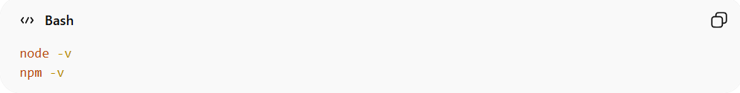
node -v
npm -v
Explain:
- node -v → Shows the installed Node.js version.
- npm -v → Shows the installed npm version.
This confirms Node.js and npm are installed correctly.

2️⃣ Create a New Project Folder
# Source: AI Source: Provided by: [Data Path: Persons Table -> ID Column: 1, Name_En Column: Motasem Essam] -> From: [ChatGPT] on [1/26/2026]
Example:
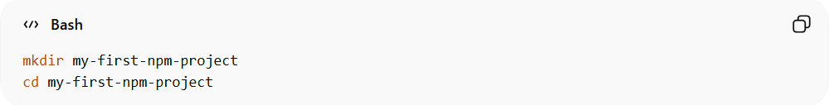
mkdir my-first-npm-project
cd my-first-npm-project
Explain:
- mkdir my-first-npm-project → Creates a new folder for your project.
- cd my-first-npm-project → Moves into that folder so we can start the project inside it.

3️⃣ Initialize npm
# Source: AI Source: Provided by: [Data Path: Persons Table -> ID Column: 1, Name_En Column: Motasem Essam] -> From: [ChatGPT] on [1/26/2026]
Creates a package.json file for your project.•

Option 1: Interactive
# Source: AI Source: Provided by: [Data Path: Persons Table -> ID Column: 1, Name_En Column: Motasem Essam] -> From: [ChatGPT] on [1/26/2026]
Example:
npm init
Explain:
- Starts an interactive setup to create package.json.
- You will enter project name, version, description, entry file, etc.
You will see questions like:

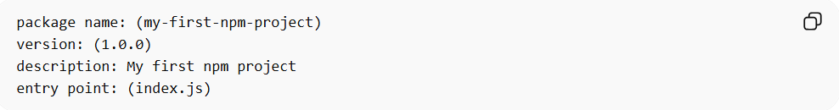
package name: (my-first-npm-project)
version: (1.0.0)
description: My first npm project
entry point: (index.js)
This creates a package.json file:
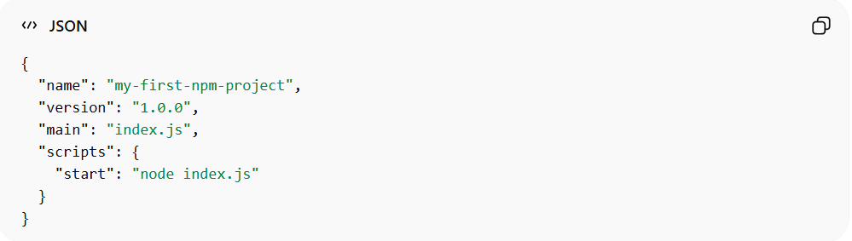
{
"name": "my-first-npm-project",
"version": "1.0.0",
"main": "index.js",
"scripts": {
"start": "node index.js"
}
}
- package.json keeps track of project info, dependencies, and scripts.

Option 2: Default/Quick mode:
# Source: AI Source: Provided by: [Data Path: Persons Table -> ID Column: 1, Name_En Column: Motasem Essam] -> From: [ChatGPT] on [1/26/2026]
Example:
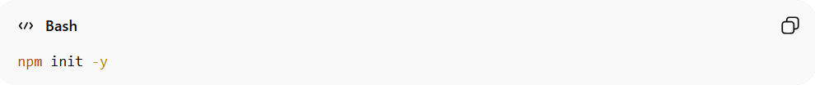
npm init -y
Explain
- Automatically creates package.json with default values.
- Skips all the questions for a faster setup.

This file manages your project settings and dependencies.

4️⃣ Install a Package

Option 1: Default (runtime) install:
# Source: AI Source: Provided by: [Data Path: Persons Table -> ID Column: 1, Name_En Column: Motasem Essam] -> From: [ChatGPT] on [1/26/2026]
Command:
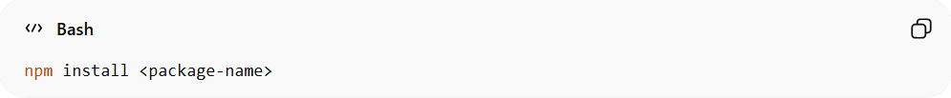
npm install <package-name>
Example:
Now install Express.js:
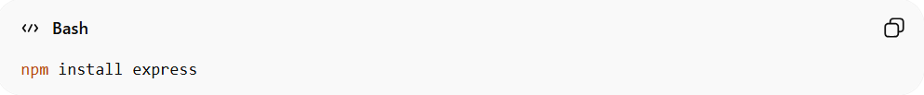
Explain:
npm install express

- npm will:
  - download the package for both development and production
  - create node_modules folder
    - node_modules is a folder automatically created by npm when you install packages (libraries).
    - It stores all the packages your project depends on, including their dependencies (other packages they need).
    - This folder can get very large because packages often rely on many other packages.
  - update package.json
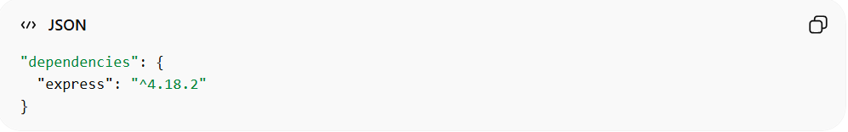
Example result:
"dependencies": {
"express": "^4.18.2"
}

Option 2: Development-only install:
# Source: AI Source: Provided by: [Data Path: Persons Table -> ID Column: 1, Name_En Column: Motasem Essam] -> From: [ChatGPT] on [1/26/2026]
Command:
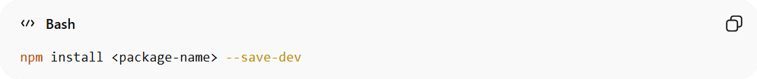
npm install <package-name> --save-dev
Example:
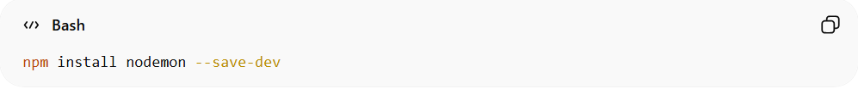
npm install nodemon --save-dev
Explain:
- Installs the package only for development purposes (not needed in production).
- Added under "devDependencies" in package.json.

5️⃣ Create Your Application
# Source: AI Source: Provided by: [Data Path: Persons Table -> ID Column: 1, Name_En Column: Motasem Essam] -> From: [ChatGPT] on [1/26/2026]
Create a file:
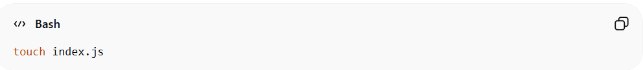
touch index.js
Example index.js content:
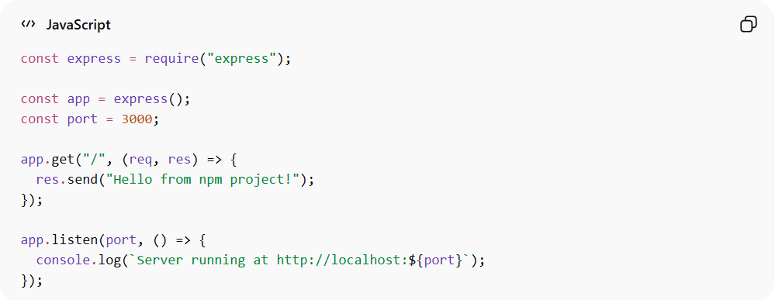
const express = require("express"); // Import Express
const app = express(); // Create an Express app
const port = 3000; // Port for server

app.get("/", (req, res) => {
res.send("Hello from npm project!"); // Response when visiting /
});

app.listen(port, () => {
console.log(`Server running at http://localhost:${port}`);
});

Explain:
- require("express") → Loads the Express library.
- app.get("/", ...) → Creates a route for the root URL (/).
- app.listen(port, ...) → Starts the server on port 3000.

6️⃣ Run the Project with npm

Option 1: Run Default script
# Source: AI Source: Provided by: [Data Path: Persons Table -> ID Column: 1, Name_En Column: Motasem Essam] -> From: [ChatGPT] on [1/26/2026]
Example:
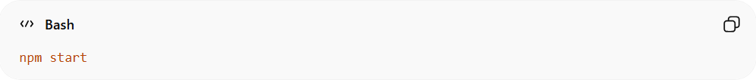
npm start

Explain:
- Runs the "start" script defined in package.json.
Because package.json contains:
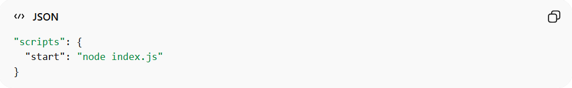
"scripts": {
"start": "node index.js"
}
- In our file, it executes node index.js, which starts the Express server.

Option 2: Run Custom script
# Source: AI Source: Provided by: [Data Path: Persons Table -> ID Column: 1, Name_En Column: Motasem Essam] -> From: [ChatGPT] on [1/26/2026]
Example:
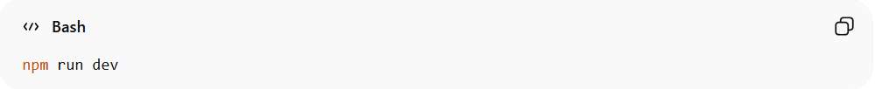
npm run dev
Explain:
- Runs any custom script defined in the "scripts" section of package.json.
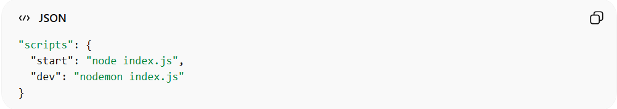
"scripts": {
"start": "node index.js",
"dev": "nodemon index.js"
}
- npm run dev will start the server using nodemon, which automatically restarts the server when files change.
- Useful for development to save time and avoid manually restarting the server.

7️⃣ Open in Browser
# Source: AI Source: Provided by: [Data Path: Persons Table -> ID Column: 1, Name_En Column: Motasem Essam] -> From: [ChatGPT] on [1/26/2026]
Visit:
http://localhost:3000
Explain:
- You should see "Hello from npm project!" in your browser.
- This confirms the server is running and serving responses.
You will see:
Hello from npm project!

Final Project Structure
# Source: AI Source: Provided by: [Data Path: Persons Table -> ID Column: 1, Name_En Column: Motasem Essam] -> From: [ChatGPT] on [1/26/2026]
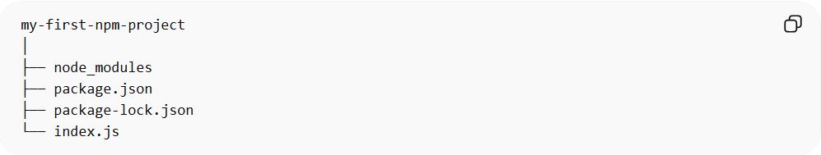
my-first-npm-project
│
├── node_modules
├── package.json
├── package-lock.json
└── index.js

Common npm Commands
# Source: AI Source: Provided by: [Data Path: Persons Table -> ID Column: 1, Name_En Column: Motasem Essam] -> From: [ChatGPT] on [1/26/2026]
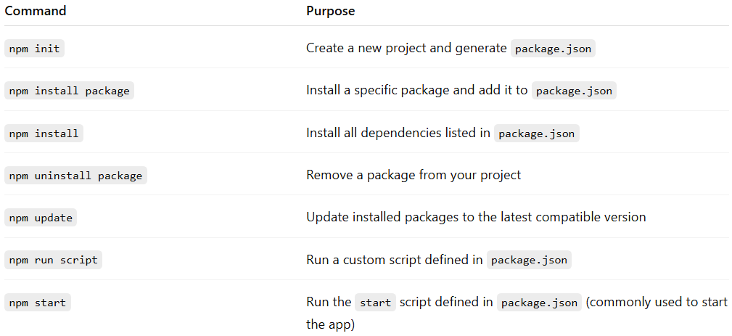
Command | Purpose
npm init | Create a new project and generate package.json
npm install package | Install a specific package and add it to package.json
npm install | Install all dependencies listed in package.json
npm uninstall package | Remove a package from your project
npm update | Update installed packages to the latest compatible version
npm run script | Run a custom script defined in package.json
npm start | Run the start script defined in package.json (commonly used to start the app)

Popular npm packages
# Source: AI Source: Provided by: [Data Path: Persons Table -> ID Column: 1, Name_En Column: Motasem Essam] -> From: [ChatGPT] on [1/26/2026]
Here’s a list of popular npm packages and what they are commonly used for. I’ll focus on packages beginners and professionals often use:

1. Express.js
# Source: AI Source: Provided by: [Data Path: Persons Table -> ID Column: 1, Name_En Column: Motasem Essam] -> From: [ChatGPT] on [1/26/2026]
Command: npm install express
Purpose:
- A fast, minimal web framework for Node.js.
- Makes building web servers and APIs easy.

2. Lodash
# Source: AI Source: Provided by: [Data Path: Persons Table -> ID Column: 1, Name_En Column: Motasem Essam] -> From: [ChatGPT] on [1/26/2026]
Command: npm install lodash
Purpose:
- Utility library for manipulating arrays, objects, and strings.
- Provides helpful functions like _.merge(), _.cloneDeep(), _.capitalize().

3. Axios
# Source: AI Source: Provided by: [Data Path: Persons Table -> ID Column: 1, Name_En Column: Motasem Essam] -> From: [ChatGPT] on [1/26/2026]
Command: npm install axios
Purpose:
- Makes HTTP requests (like fetching data from APIs) easier than using Node’s built-in modules.

4. Mongoose
# Source: AI Source: Provided by: [Data Path: Persons Table -> ID Column: 1, Name_En Column: Motasem Essam] -> From: [ChatGPT] on [1/26/2026]
Command: npm install mongoose
Purpose:
- Connects Node.js to MongoDB databases.
- Provides schemas, models, and validations for database operations.

5. Dotenv
# Source: AI Source: Provided by: [Data Path: Persons Table -> ID Column: 1, Name_En Column: Motasem Essam] -> From: [ChatGPT] on [1/26/2026]
Command: npm install dotenv
Purpose:
- Loads environment variables from a .env file.
- Keeps API keys and secrets out of your code.

6. Body-Parser (older Express projects)
# Source: AI Source: Provided by: [Data Path: Persons Table -> ID Column: 1, Name_En Column: Motasem Essam] -> From: [ChatGPT] on [1/26/2026]
Command: npm install body-parser
Purpose:
- Helps parse incoming HTTP request data (like JSON or URL-encoded forms).

7. Nodemon
# Source: AI Source: Provided by: [Data Path: Persons Table -> ID Column: 1, Name_En Column: Motasem Essam] -> From: [ChatGPT] on [1/26/2026]
Command: npm install nodemon --save-dev
Purpose:
- Automatically restarts your Node.js server when files change.
- Used mainly in development.

8. Cors
# Source: AI Source: Provided by: [Data Path: Persons Table -> ID Column: 1, Name_En Column: Motasem Essam] -> From: [ChatGPT] on [1/26/2026]
Command: npm install cors
Purpose:
- Enables Cross-Origin Resource Sharing in your server.
- Allows your API to be accessed from other domains.

9. Chalk
# Source: AI Source: Provided by: [Data Path: Persons Table -> ID Column: 1, Name_En Column: Motasem Essam] -> From: [ChatGPT] on [1/26/2026]
Command: npm install chalk
Purpose:
- Adds colors and styles to console output.
- Makes logs easier to read during development.

10. Jest
# Source: AI Source: Provided by: [Data Path: Persons Table -> ID Column: 1, Name_En Column: Motasem Essam] -> From: [ChatGPT] on [1/26/2026]
Command: npm install jest --save-dev
Purpose:
- Testing framework for JavaScript.
- Lets you write unit tests for your code.

✅ Summary:
# Source: AI Source: Provided by: [Data Path: Persons Table -> ID Column: 1, Name_En Column: Motasem Essam] -> From: [ChatGPT] on [1/26/2026]
- Express, Axios, Mongoose → for building apps and working with databases.
- Lodash, Dotenv, Chalk → utility and developer tools.
- Nodemon, Jest, Body-Parser, Cors → development helpers and testing.

Installing a package globally or locally
# Source: AI Source: Provided by: [Data Path: Persons Table -> ID Column: 1, Name_En Column: Motasem Essam] -> From: [ChatGPT] on [1/26/2026]
Sure! Let’s break it down clearly. In Node.js and npm, installing a package globally or locally refers to where the package is installed and where you can use it.

1️⃣ Local Installation
# Source: AI Source: Provided by: [Data Path: Persons Table -> ID Column: 1, Name_En Column: Motasem Essam] -> From: [ChatGPT] on [1/26/2026]
Command:
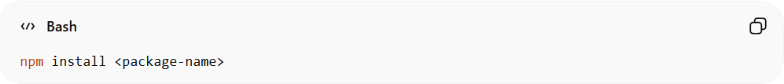
npm install <package-name>
Explain:
- Installs the package inside your project folder (in node_modules).
- Only this project can use the package.
- Adds the package to your package.json under "dependencies" or "devDependencies".
- Example:
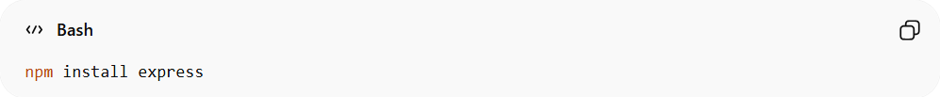
npm install express
- express can now be used only in this project.
- Great for libraries your code depends on.

2️⃣ Global Installation
# Source: AI Source: Provided by: [Data Path: Persons Table -> ID Column: 1, Name_En Column: Motasem Essam] -> From: [ChatGPT] on [1/26/2026]
Command:
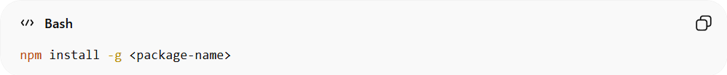
npm install -g <package-name>
Explain:
- Installs the package system-wide on your computer.
- You can use it in any project or even from the command line.
- Usually used for command-line tools or utilities.
- Example:
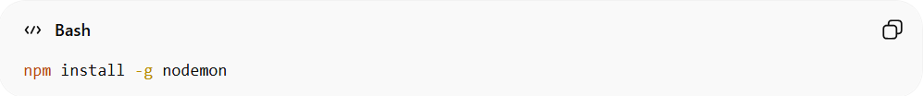
npm install -g nodemon
- nodemon can now be run in any project or folder by just typing:
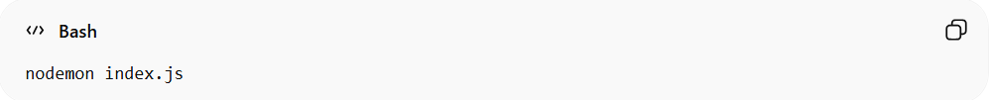
nodemon index.js

Difference Between Local & Global
# Source: AI Source: Provided by: [Data Path: Persons Table -> ID Column: 1, Name_En Column: Motasem Essam] -> From: [ChatGPT] on [1/26/2026]
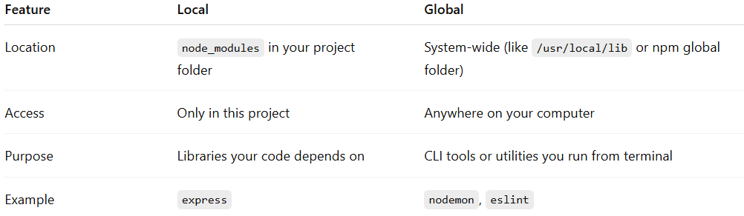
Feature | Local | Global
Location | node_modules in your project folder | System-wide (like /usr/local/lib or npm global folder)
Access | Only in this project | Anywhere on your computer
Purpose | Libraries your code depends on | CLI tools or utilities you run from terminal
Example | express | nodemon, eslint

✅ In short:
# Source: AI Source: Provided by: [Data Path: Persons Table -> ID Column: 1, Name_En Column: Motasem Essam] -> From: [ChatGPT] on [1/26/2026]
- Local → “I need this library only for this project.”
- Global → “I want this tool available everywhere on my computer.”

npx

What is npx?
# Source: AI Source: Provided by: [Data Path: Persons Table -> ID Column: 1, Name_En Column: Motasem Essam] -> From: [ChatGPT] on [1/26/2026]
npx is a command that comes with npm (Node Package Manager).
It allows you to run Node.js packages without installing them globally on your computer.

Key Points
# Source: AI Source: Provided by: [Data Path: Persons Table -> ID Column: 1, Name_En Column: Motasem Essam] -> From: [ChatGPT] on [1/26/2026]
- Run packages temporarily
  - You don’t need to install the package globally with npm install -g.
  - Example:
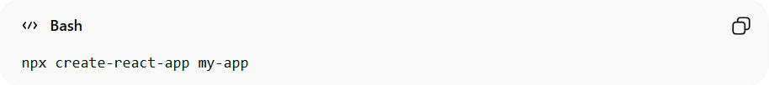
npx create-react-app my-app
    - This runs create-react-app once to create a new React project.
- Execute package commands in one line
  - Useful for running CLI tools or initializers directly.
  - Example:
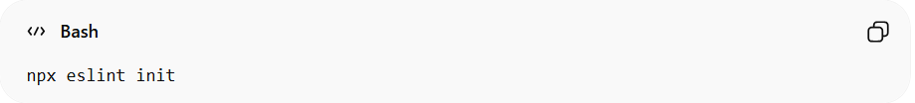
npx eslint init
    - Sets up ESLint in your project folder.
- Always uses the latest version
  - npx downloads the latest version of the package for temporary use, ensuring your project uses up-to-date tools.

Difference from npm
# Source: AI Source: Provided by: [Data Path: Persons Table -> ID Column: 1, Name_En Column: Motasem Essam] -> From: [ChatGPT] on [1/26/2026]
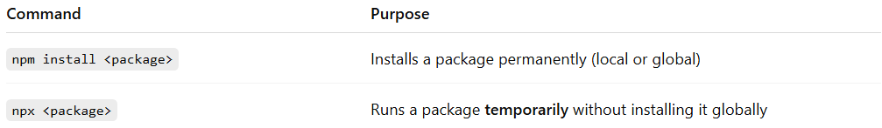
Command | Purpose
npm install <package> | Installs a package permanently (local or global)
npx <package> | Runs a package temporarily without installing it globally

Example Use Cases
# Source: AI Source: Provided by: [Data Path: Persons Table -> ID Column: 1, Name_En Column: Motasem Essam] -> From: [ChatGPT] on [1/26/2026]
- Create a new project
Creates a new project folder with all boilerplate files and dependencies.
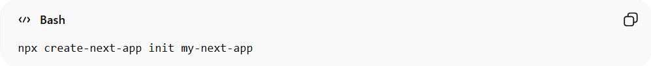
npx create-next-app init my-next-app
Explain:
- npx → Runs the package temporarily without installing it globally.
- create-next-app → The package that provides a Next.js project template.
- init → Command to initialize a new project.
- my-next-app → Name of the folder for your new project.
- What happens:
  - A folder called my-next-app is created.
  - All Next.js boilerplate files, configuration, and dependencies are set up automatically.
  - You can immediately start development with npm run dev.
- Initialize tooling in an existing project
Sets up ESLint configuration and dependencies in your current project.
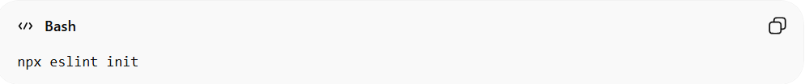
npx eslint init
Explain:
- npx → Runs ESLint temporarily without global installation.
- eslint → The package that provides a linter to check your code for errors and enforce style rules.
- init → Starts ESLint’s interactive setup in the current project folder.
- What happens:
  - ESLint configuration file (.eslintrc.json) is created.
  - Necessary ESLint packages are installed in node_modules.
  - Your existing project is now set up for linting and code quality checks.
- Run a package command once
Runs a one-time command from a cowsay package without installing it globally.
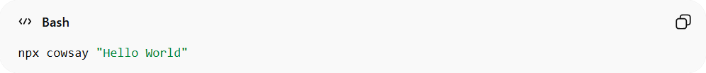
npx cowsay "Hello World"
Explain:
- npx → Runs the package temporarily without installing it globally.
- cowsay → A fun CLI tool that prints an ASCII cow saying your message.
- "Hello World" → The message that the cow will “say.”
- What happens:
  - You see a cute ASCII cow in the terminal with the message:
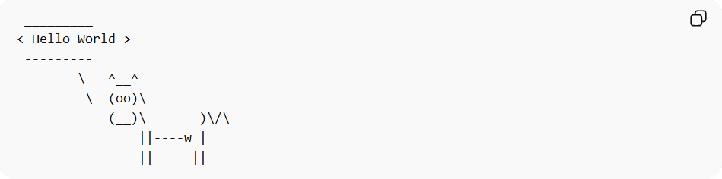
_________
< Hello World >
---------
\ ^__^
\ (oo)\_______
(__)\ )\/\
||----w |
|| ||
  - You do not need to install cowsay globally to try it.
  - Perfect for testing npx or running one-off package commands.

In short:
# Source: AI Source: Provided by: [Data Path: Persons Table -> ID Column: 1, Name_En Column: Motasem Essam] -> From: [ChatGPT] on [1/26/2026]
npx = “run Node.js packages instantly without installing globally”

Does npm belong to package managers, dependency managers, or both?
# Source: AI Source: Provided by: [Data Path: Persons Table -> ID Column: 1, Name_En Column: Motasem Essam] -> From: [ChatGPT] on [1/26/2026]
npm primarily functions as a dependency manager, because its main role is to manage project-specific libraries. However, it can also act as a package manager when installing global Node.js tools.
npm belongs to both categories, but in context it’s primarily a dependency manager for Node.js projects. Let me break it down clearly:

1️⃣ Dependency Manager
# Source: AI Source: Provided by: [Data Path: Persons Table -> ID Column: 1, Name_En Column: Motasem Essam] -> From: [ChatGPT] on [1/26/2026]
- Primary role: Manages project-specific libraries (dependencies) that your Node.js project needs to run.
- Example:
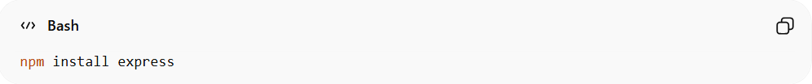
npm install express
- Installs the Express library only for this project (unless -g is used for global CLI tools).
- Updates package.json and package-lock.json automatically.

2️⃣ Package Manager
# Source: AI Source: Provided by: [Data Path: Persons Table -> ID Column: 1, Name_En Column: Motasem Essam] -> From: [ChatGPT] on [1/26/2026]
- Secondary role: Can also install Node.js packages globally, acting like a system-level package manager for Node.js tools.
- Example:
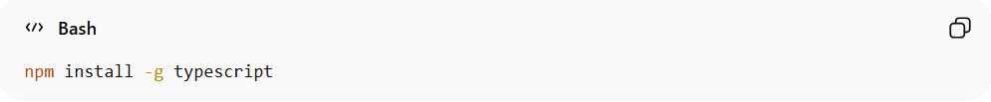
npm install -g typescript
- Installs TypeScript CLI globally, making it available anywhere on your system.

✅ Summary
# Source: AI Source: Provided by: [Data Path: Persons Table -> ID Column: 1, Name_En Column: Motasem Essam] -> From: [ChatGPT] on [1/26/2026]
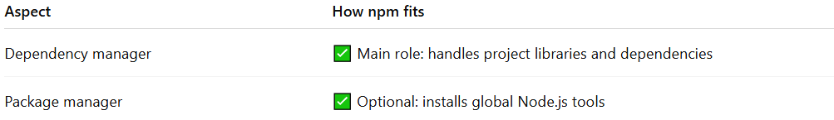
Aspect | How npm fits
Dependency manager | ✅ Main role: handles project libraries and dependencies
Package manager | ✅ Optional: installs global Node.js tools
Key takeaway:
- npm = primarily a dependency manager for your project.
- It can act as a package manager for global Node.js tools.

📌 Summary
# Source: AI Source: Provided by: [Data Path: Persons Table -> ID Column: 1, Name_En Column: Motasem Essam] -> From: [ChatGPT] on [1/26/2026]
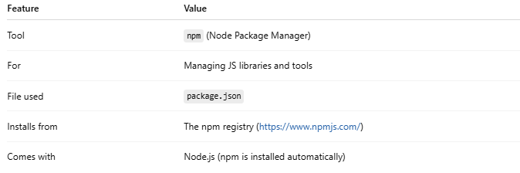

Feature | Value
Tool | npm (Node Package Manager)
For | Managing JS libraries and tools
File used | package.json
Installs from | The npm registry (https://www.npmjs.com/)
Comes with | Node.js (npm is installed automatically)

With npm you can:
- create projects
- install libraries
- manage dependencies
- run scripts
publish packages

